Physics Name: ________________________
Light Stuff

1. What is light? Electromagnetic radiation with wavelengths between 390 and 740nm

The “wave-particle duality” of light (and all electromagnetic radiation):

2. How is light like a particle?

- It is made up of particles, called “photons”
- It has momentum. It can push against things
- Light is pulled by gravity
- It can travel in a vacuum
3. How is light is like a wave?

- It is an oscillation with measurable wavelength, frequency, etc.
- It has other wave properties: reflection, refraction, scattering

The Electromagnetic Spectrum

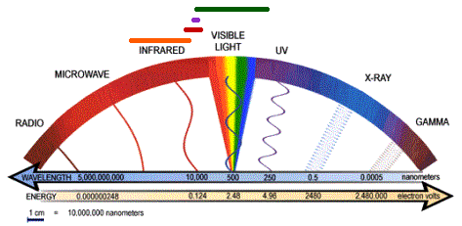

4. Light waves from longest to shortest wavelength:
5. Nicknames for The Two Ends Of The Spectrum:

- The long-wavelength end of the visible spectrum is called the ___________________ end.

- The short-wavelength end of the visible spectrum is called the ___________________ end.

6. Describe two ways to show that white light is actually made up of a rainbow of colors?

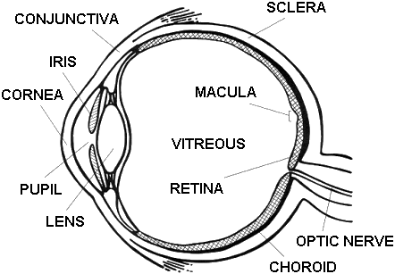
7. Show how the human eye sees.
8. Can you find the blind spot created by your optic nerve?

9. Star Colors

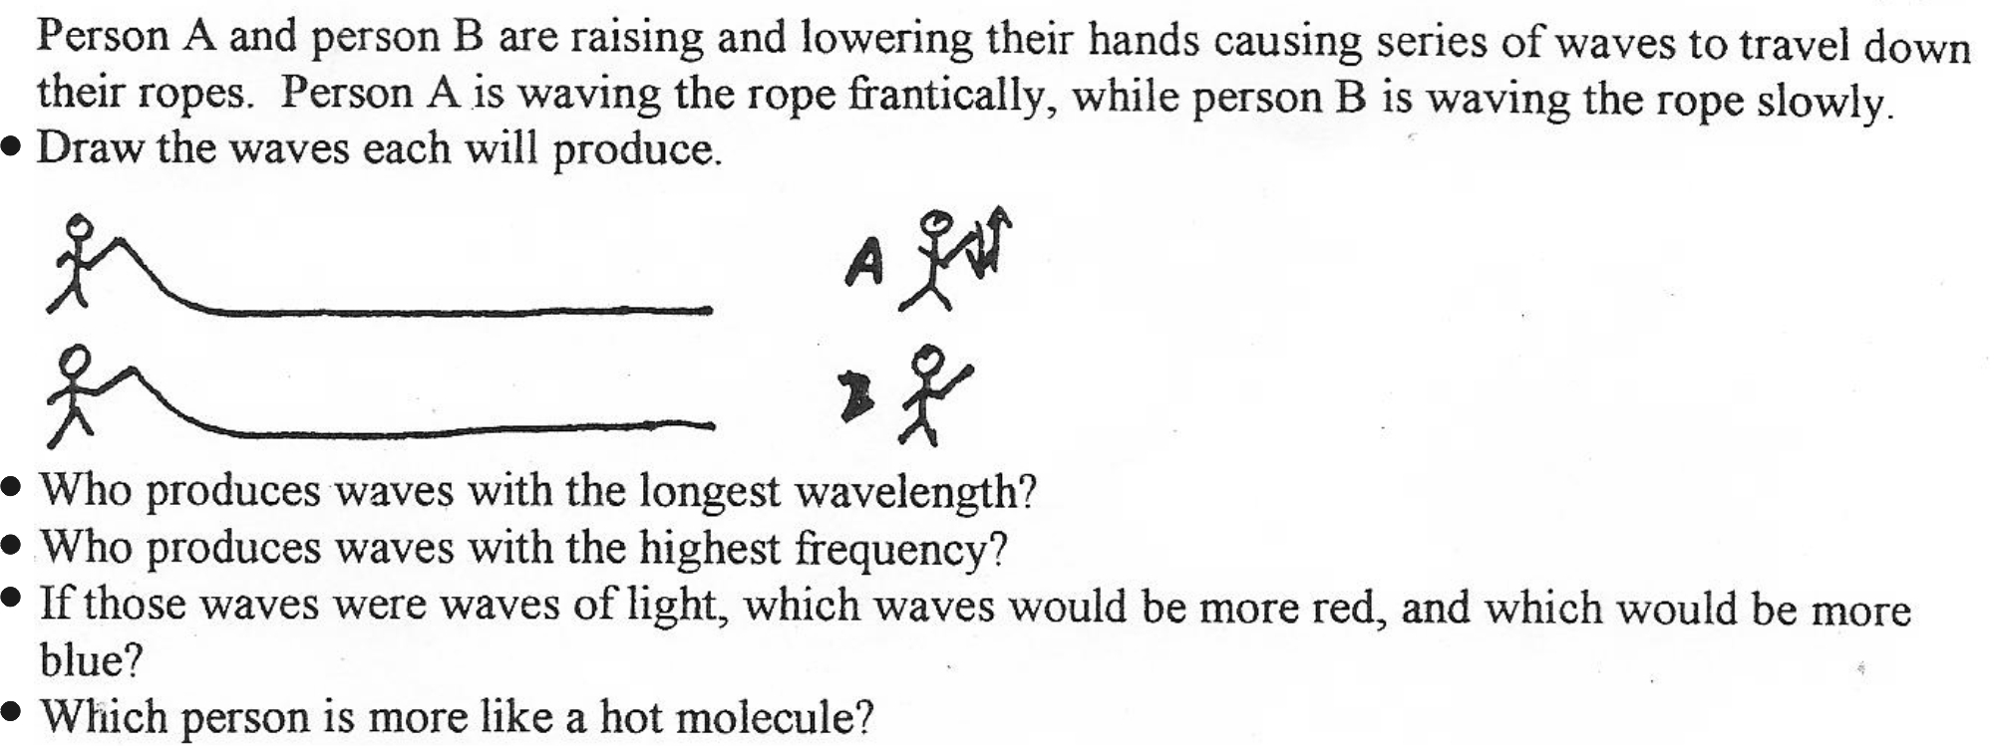

10. What colors are the hottest and coolest stars?

11. Why are there no green stars?
12. All other things being equal (**like number of photons and coherence) what frequencies of electromagnetic radiation most dangerous?

13. Why?

14. Ordinary (incoherent) light waves:

15. *Coherent light waves (found in ____________________):

Wave Behaviors:

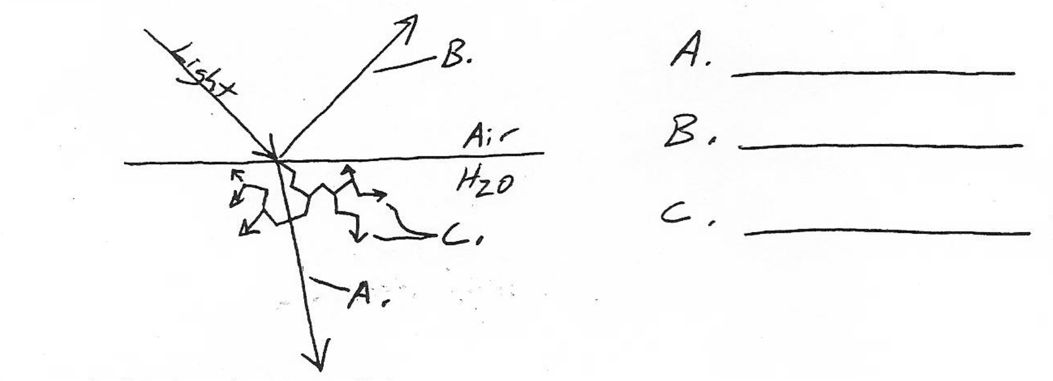
Refraction (Bending) of Light

16. What is special about the speed of light?
- It’s the speed limit
- No matter how you measure it, it’s always the same, relative to you.

17. One of these properties prompted Einstein to propose the theory of Relativity. Among other things, the theory of relativity states that, when you move faster….

18. How has that been proven?

19. What is the speed of light, in a vacuum?

20. What is a “light year?”
5.87x10¹² miles

21. How long does it take sunlight to reach the Earth?

22. If there were a mirror on the moon, and you could use a telescope to look at yourself in that
mirror, what would you see? You would see what you were doing 2.6s ago.

23. If the speed of light is constant, why does it travel more slowly through things like glass?

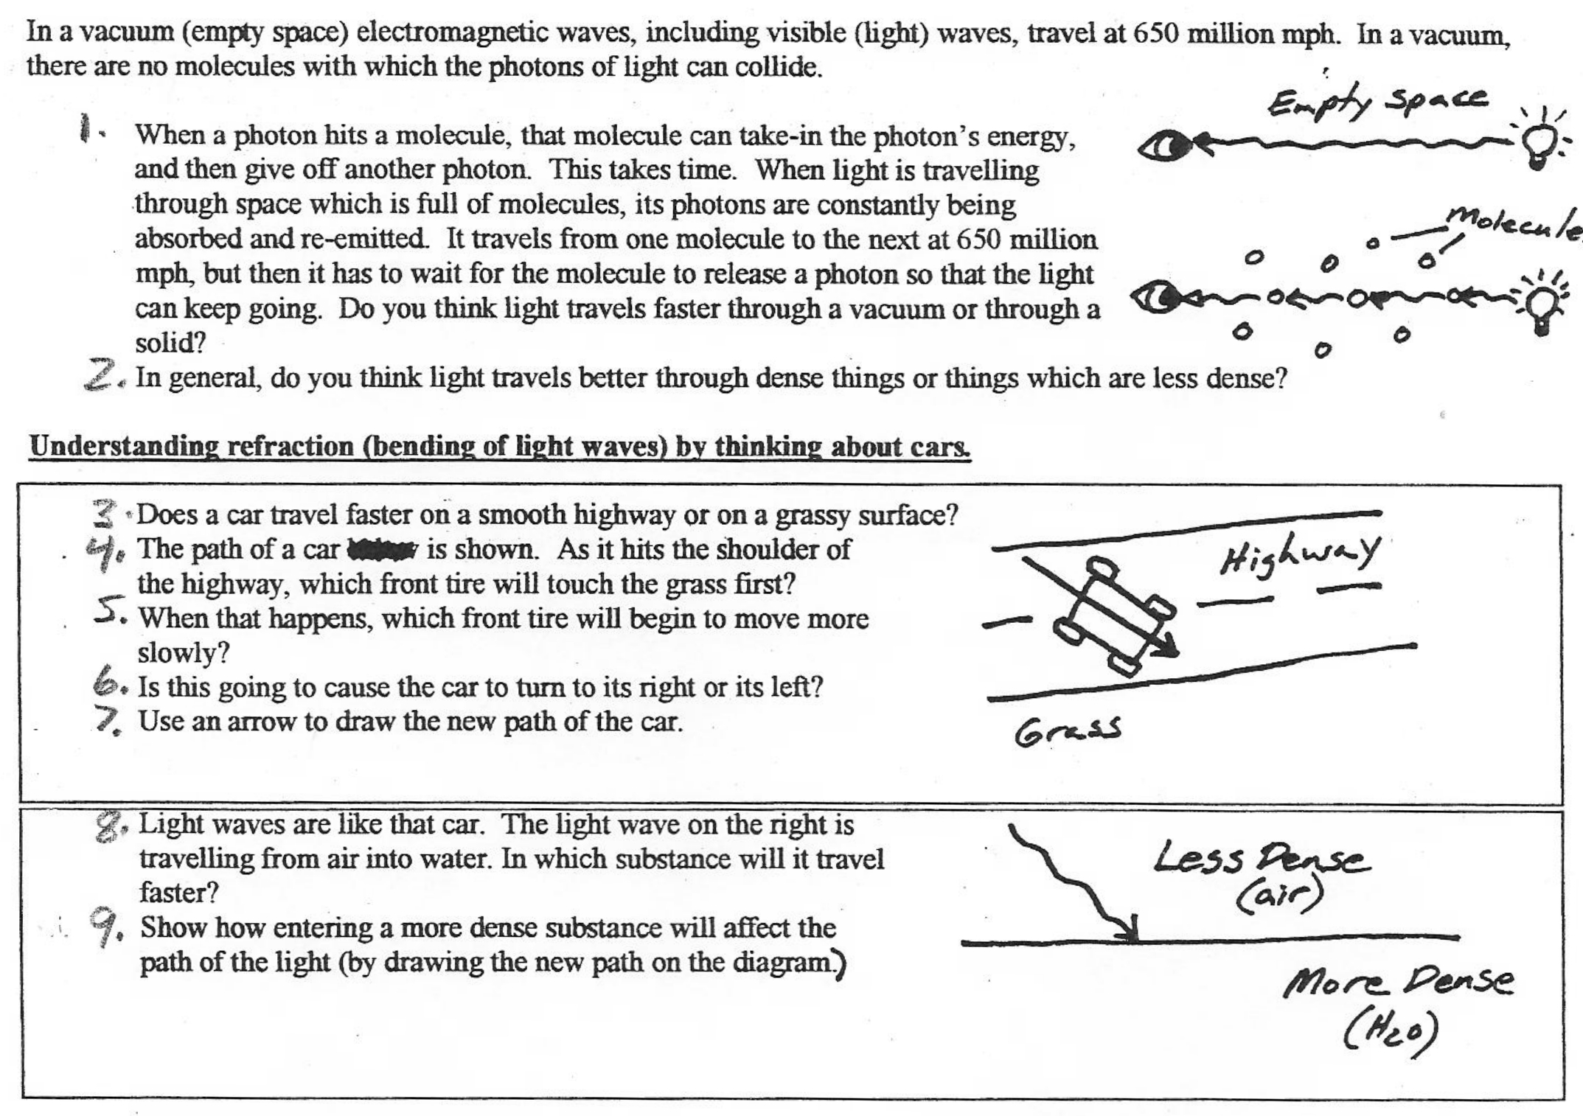

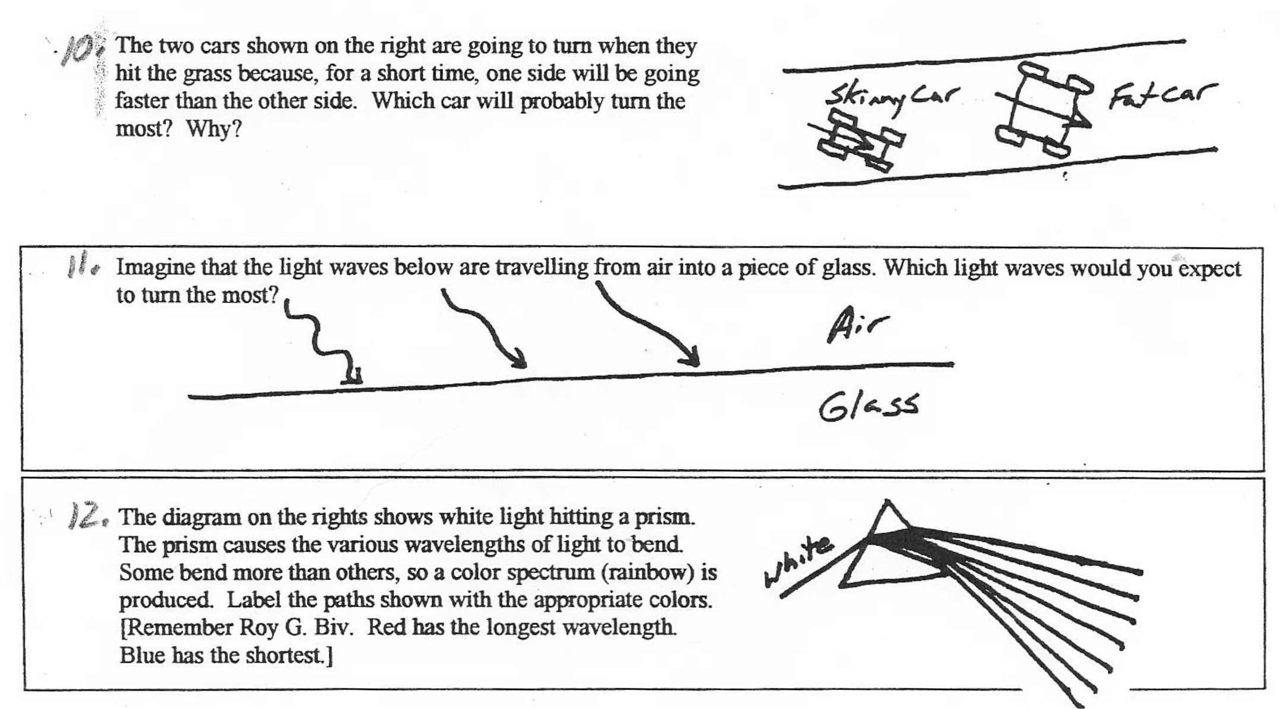

13. When light refracts (bends), it turns __________________ (toward or away from) the medium in which it travels more slowly.

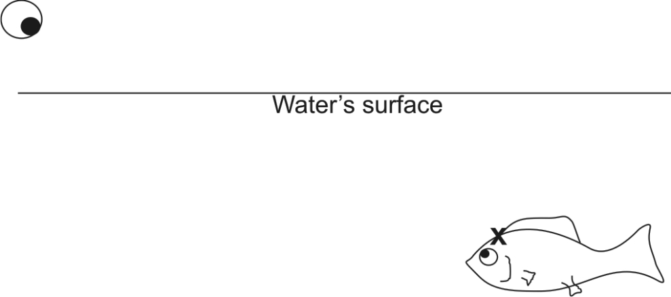
14. The eyeball is looking at the fish. It would like to shoot the fish right on the "x." The problem is that the eyeball "sees" the x in a place that really is not the true location of the fish. Draw the x where the eyeball sees it, and show the path of light traveling from the x to the eyeball.

If you want to shoot a fish, where should you aim?

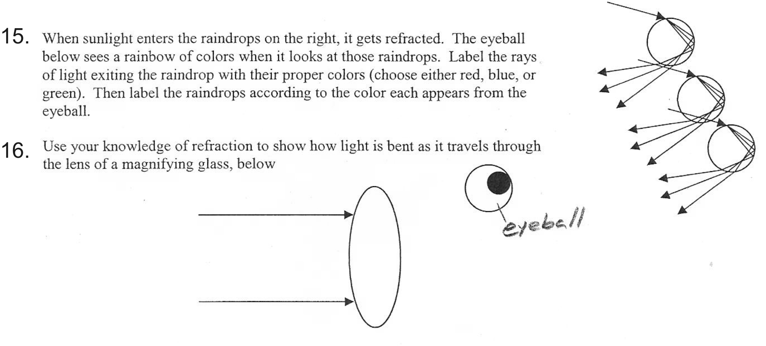

Reflection of Light

1. The diagram below shows how a flashlight mirror reflects light from the bulb and directs it forward in a straight beam. Show how you can use a flashlight mirror to start a fire.



Scattering of Light In Our Atmosphere:
A way to remember which waves get scattered in our atmosphere [**This is not an explanation of why scattering occurs. It is a mnemonic device.**]
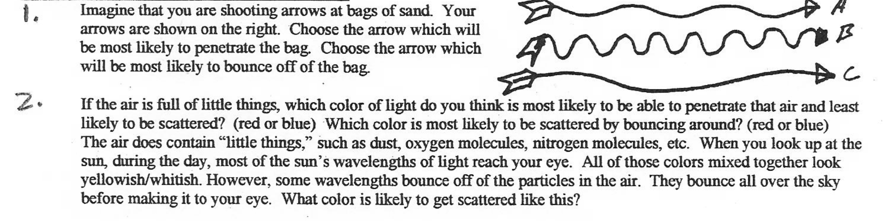
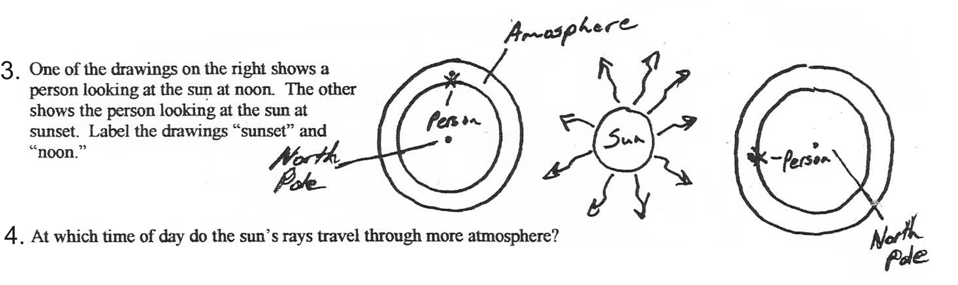
Why is the sky blue? [On the moon, the sky looks black.]

Why does the sun turn red at sunset?

